System Interaction Architecture

Enterprise System Complexity
Item-Centric Architecture in NetSuite
Master Data Dependencies & Financial Behavior Through Items
Weekly Learning Series – Week 7

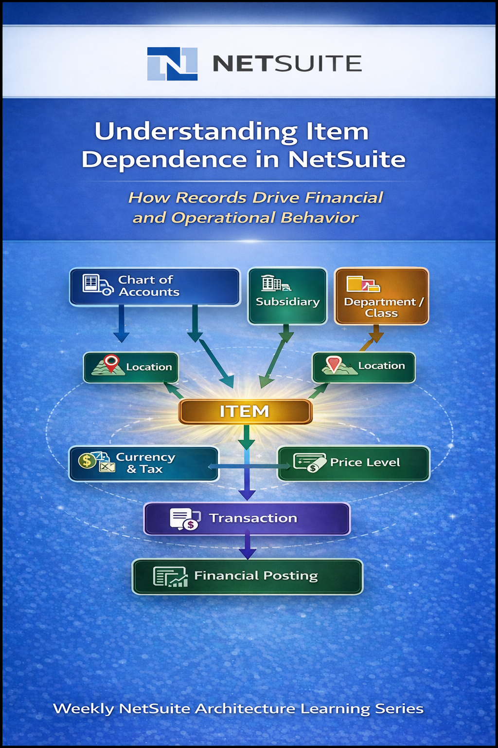

Why Items Are More Than Just Records
- In NetSuite, an Item is not just a product or service. It is the point where operational activity becomes financial reality.
- Every transaction flow through an Item, making it the control layer for revenue recognition, cost recording, inventory valuation, and reporting classification.
- Because of this, Items do not operate independently. Their behaviour is defined by the master data that surrounds them.
- Understanding these dependencies is essential to understanding how NetSuite behaves as a system.

Item & Master Interdependency Model
- In NetSuite, an Item is not just a product record. It is the point where financial and operational data converge.
- Every transaction flow through the Item, making it the control layer for posting logic, reporting classification, and operational behaviour.
- Because of this, Items exist within a multi-master dependency model, where even small changes in master data can ripple across transactions and financial outcomes.

Core Master Dependencies
- An Item in NetSuite is shaped by the master data surrounding it. It does not carry meaning on its own.
- Its behavior is defined through its interaction with
  - Chart of Accounts
  - Subsidiary
  - Location
  - Department and Class
  - Currency
  - Tax Codes
  - Accounting Period
  - Price Levels
- Each dependency adds a layer of context, determining how transactions are posted, classified, valued, and reported. Without these, an Item is just a record. With them, it becomes a financial control point.

Chart of Accounts Dependency
- The Chart of Accounts is what turns an Item transaction into a financial event.
- Every Item is linked to critical accounts such as:
- Income
- Cost of Goods Sold (COGS)
- Inventory Asset
- Expense
- Deferred Revenue
- These mappings define how revenue is recognized, how costs are recorded, and how inventory is valued in the General Ledger.
- If these accounts are misconfigured or changed without alignment, the result is not a small error, it is distorted financial reporting.

Subsidiary Dependency
- In NetSuite OneWorld, an Item does not exist globally. It operates within the boundaries of a subsidiary, a defined legal and financial entity.
- Items must be explicitly enabled per subsidiary, making their behaviour context-dependent rather than universal.
- Each subsidiary controls critical dimensions such as:
- Financial accounts
- Base currency
- Tax rules
- Legal reporting requirements
- This means an Item can behave differently across subsidiaries. If configuration is not aligned, transactions may be posted to the wrong accounts, currencies, or tax structures, leading to compliance and reporting issues.

Location Dependency
- In NetSuite, inventory is not tracked globally, it is controlled at the location level.
- An Item’s availability, valuation, and movement are all determined by the location it is assigned to.
- This includes:
- Inventory availability
- Inventory valuation
- Costing layers
- Fulfilment processes
- As a result, incorrect location assignment does not just affect operations, it directly distorts inventory valuation and financial reporting.

Department and Class Dependency
- Departments and Classes determine how transactions are classified for internal reporting.
- When Items are used in transactions, they carry these dimensions, enabling financial data to be segmented across the organization.
- This allows performance analysis across:
- Business units
- Product categories
- Operational divisions
- Without these classifications, financial data exists, but it lacks structure for meaningful analysis.

Currency Dependency
- In multi-currency environments, an Item’s value is not fixed, it is interpreted through currency and exchange rates.
- Every transaction involving an Item depends on:
- Currency conversion
- Exchange rate application
- Multi-currency reporting adjustments
- These elements determine how revenue and costs are translated across subsidiaries and financial reports.
- If currency configuration is incorrect, the result is not just operational error, it is distorted financial reporting.

Tax Code Dependency
- Tax codes control how Item transactions are taxed across jurisdictions.
- Each Item is linked to tax schedules that define:
- Applicable tax rates
- Tax jurisdictions
- Tax exemptions
- This configuration ensures that transactions comply with local tax regulations and reporting requirements.
- If tax configuration is incorrect, the impact is not just reporting error, it is regulatory non-compliance.

Accounting Period Dependency
- Accounting periods control when the financial impact of an Item is recognized.
- Every Item transaction is tied to a specific period, influencing how cost, revenue, and inventory are recorded.
- This includes:
- Cost recognition within defined periods
- Revenue recognition aligned with accounting schedules
- Inventory adjustments affecting period-based financial statements
- Backdated transactions do not just update records, they alter historical financial results and can distort previously reported data.

Price Level Dependency
- Price Levels determine how the value of an Item is presented to different customer segments.
- The same Item can carry multiple pricing structures, such as:
- Retail pricing
- Wholesale pricing
- Distributor pricing
- Contract pricing
- This allows organizations to segment customers without duplicating Items, while controlling pricing strategy at scale.
- As a result, pricing becomes flexible at the transaction level while remaining centrally governed.

System Interaction Model
- The interaction between Items and master data forms a centralized dependency model.
- Items act as the control layer through which operational transactions are translated into financial outcomes.
- Every transaction flow through the Item, which applies context from master data such as accounts, subsidiaries, locations, taxes, and pricing.
- As a result, Items are not just records, they are the point where operational activity becomes financial reality.
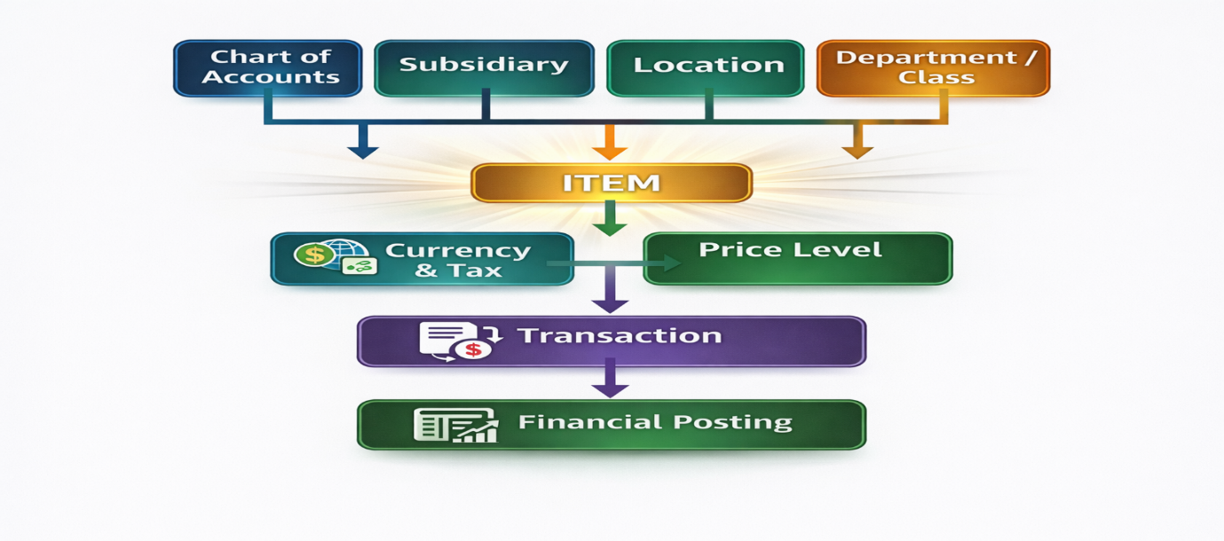
Architectural Insight
- Items are not just product records; they are the control layer that translates operational activity into financial outcomes.
- They sit at the intersection of multiple master data structures, integrating accounts, subsidiaries, locations, taxes, and pricing into every transaction.
- Because of this, any change in master data does not remain isolated, it propagates through Items into financial reporting and system behaviour.
- Without strong governance, Item configuration becomes a source of financial inconsistency, reporting errors, and operational risk.

